Risk Response Planning and Risk Control

1-Risk Response Planning

🔹 Definition
# Source: AI Source: Provided by: [Data Path: Persons Table -> ID Column: 1, Name_En Column: Motasem Essam] -> From: [Chatgpt (GPT‑5 Mini)] on [8/24/2025]
Risk Response Planning is the process of developing strategies and actions to address identified risks to minimize their impact or likelihood on a project, product, or business objective.
It is a key step in risk management that comes after risk identification, analysis, and prioritization.

🛠️ Objectives of Risk Response Planning
# Source: AI Source: Provided by: [Data Path: Persons Table -> ID Column: 1, Name_En Column: Motasem Essam] -> From: [Chatgpt (GPT‑5 Mini)] on [8/24/2025]
- Define how each risk will be handled.
- Reduce probability or impact of negative risks (threats).
- Maximize opportunities (positive risks).
- Ensure resources are allocated effectively for risk mitigation.
- Provide clear action plans for the project team.

🔹 Risk Response strategy
# Source: AI Source: Provided by: [Data Path: Persons Table -> ID Column: 1, Name_En Column: Motasem Essam] -> From: [Chatgpt (GPT‑5 Mini)] on [8/24/2025]
In risk management, risks can be threats (negative) or opportunities (positive).
Here’s the full set of risk response strategies:

🔴 Responses to Negative Risks (Threats)

1. Risk Avoidance 🛑
# Source: AI Source: Provided by: [Data Path: Persons Table -> ID Column: 1, Name_En Column: Motasem Essam] -> From: [Chatgpt (GPT‑5 Mini)] on [8/24/2025]
Definition:
Completely eliminate the risk by removing its cause or changing the plan so the risk cannot occur.
Example:
- Risk: Developing a feature using a new, unstable technology might cause delays.
- Avoidance: Decide to use a proven, stable technology instead.
Pros:
- Eliminates the risk entirely.
- Provides certainty.
Cons:
- May limit innovation or opportunities.
- Could lead to higher costs.
When to Use:
- For high-impact, unacceptable risks.
- When safer alternatives exist.

2. Risk Mitigation 🔧
# Source: AI Source: Provided by: [Data Path: Persons Table -> ID Column: 1, Name_En Column: Motasem Essam] -> From: [Chatgpt (GPT‑5 Mini)] on [8/24/2025]
Definition:
Take actions to reduce the likelihood of the risk happening or minimize its impact.
Example:
- Risk: Server may crash during peak traffic.
- Mitigation: Add backup servers and stress test systems.
Pros:
- Reduces both probability and impact.
- Keeps the project on track.
Cons:
- Does not remove risk fully.
- May require extra resources.
When to Use:
- When the risk cannot be avoided but can be minimized.

3. Risk Transfer 📤
# Source: AI Source: Provided by: [Data Path: Persons Table -> ID Column: 1, Name_En Column: Motasem Essam] -> From: [Chatgpt (GPT‑5 Mini)] on [8/24/2025]
Definition:
Shift the responsibility and financial impact of the risk to a third party.
Example:
- Risk: Equipment may be damaged in transit.
- Transfer: Purchase insurance or hire a logistics company that assumes liability.
Pros:
- Protects finances.
- Offloads responsibility.
Cons:
- Extra costs (insurance premiums, service fees).
- Risk still exists, just shifted.
When to Use:
- For financial risks that can be insured.
- When others are better equipped to manage the risk.

4. Risk Acceptance ✅
# Source: AI Source: Provided by: [Data Path: Persons Table -> ID Column: 1, Name_En Column: Motasem Essam] -> From: [Chatgpt (GPT‑5 Mini)] on [8/24/2025]
Definition:
Acknowledge the risk but take no immediate action, either because it is small or because response costs outweigh benefits.
Example:
- Risk: Minor 1–2 day vendor delay may occur.
- Acceptance: Decide to live with it.
Pros:
- Saves cost/time.
- Practical for small risks.
Cons:
- Could escalate if underestimated.
- May seem careless without communication.
When to Use:
- For low-impact, low-likelihood risks.
- When cost of response > cost of risk.

🟢 Responses to Positive Risks (Opportunities)

5. Risk Exploitation 🚀
# Source: AI Source: Provided by: [Data Path: Persons Table -> ID Column: 1, Name_En Column: Motasem Essam] -> From: [Chatgpt (GPT‑5 Mini)] on [8/24/2025]
Definition:
Take actions to ensure the opportunity definitely occurs and deliver maximum benefit.
Example:
- Opportunity: A new technology can cut project time in half.
- Exploitation: Dedicate resources to adopt it immediately.
Pros:
- Guarantees the opportunity is realized.
- Maximizes potential gains.
Cons:
- May require upfront cost or reallocation of resources.
When to Use:
- When the opportunity has high benefits and is achievable.

6. Risk Enhancement 📈
# Source: AI Source: Provided by: [Data Path: Persons Table -> ID Column: 1, Name_En Column: Motasem Essam] -> From: [Chatgpt (GPT‑5 Mini)] on [8/24/2025]
Definition:
Increase the probability or impact of an opportunity to maximize its benefits.
Example:
- Opportunity: A skilled developer may finish a critical task faster.
- Enhancement: Assign additional support staff to enable even faster delivery.
Pros:
- Increases likelihood and/or benefit of opportunities.
- Strengthens positive outcomes.
Cons:
- Additional cost or effort needed.
- No guarantee of success.
When to Use:
- When there’s a good chance of improving an opportunity.
- When small boosts can create big benefits.

7. Risk Sharing 🤝
# Source: AI Source: Provided by: [Data Path: Persons Table -> ID Column: 1, Name_En Column: Motasem Essam] -> From: [Chatgpt (GPT‑5 Mini)] on [8/24/2025]
Definition:
Partner with a third party to share ownership of an opportunity, combining strengths to maximize benefit.
Example:
- Opportunity: Entering a new market can increase profits.
- Sharing: Form a joint venture with a local partner.
Pros:
- Leverages combined expertise/resources.
- Reduces cost and increases reach.
Cons:
- Shared control and profit.
- Possible dependency on the partner.
When to Use:
- When opportunities need external expertise or resources.
- When collaboration increases chances of success.

8. Risk Acceptance (Opportunity) 🤷‍♂️
# Source: AI Source: Provided by: [Data Path: Persons Table -> ID Column: 1, Name_En Column: Motasem Essam] -> From: [Chatgpt (GPT‑5 Mini)] on [8/24/2025]
Definition:
Acknowledge the opportunity but do nothing special to pursue it, leaving it to chance.
Example:
- Opportunity: A vendor may deliver early.
- Acceptance: No special action is taken; if it happens, that’s great.
Pros:
- Saves cost and effort.
- Simple approach.
Cons:
- Opportunity may be lost.
- No guarantee of benefit.
When to Use:
- For small, low-impact opportunities.
- When pursuing it is not cost-effective.

📌 Summary Table
# Source: AI Source: Provided by: [Data Path: Persons Table -> ID Column: 1, Name_En Column: Motasem Essam] -> From: [Chatgpt (GPT‑5 Mini)] on [8/24/2025]
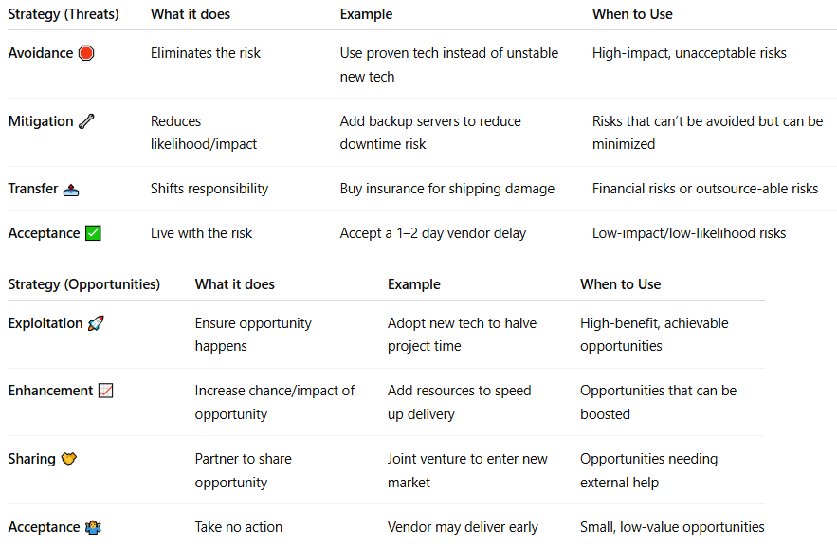
Strategy (Threats) | What it does | Example | When to Use
Avoidance 🛑 | Eliminates the risk | Use proven tech instead of unstable new tech | High-impact, unacceptable risks
Mitigation 🔧 | Reduces likelihood/impact | Add backup servers to reduce downtime risk | Risks that can’t be avoided but can be minimized
Transfer 📤 | Shifts responsibility | Buy insurance for shipping damage | Financial risks or outsource-able risks
Acceptance ✅ | Live with the risk | Accept a 1–2 day vendor delay | Low-impact/low-likelihood risks

Strategy (Opportunities) | What it does | Example | When to Use
Exploitation 🚀 | Ensure opportunity happens | Adopt new tech to halve project time | High-benefit, achievable opportunities
Enhancement 📈 | Increase chance/impact of opportunity | Add resources to speed up delivery | Opportunities that can be boosted
Sharing 🤝 | Partner to share opportunity | Joint venture to enter new market | Opportunities needing external help
Acceptance 🤷‍♂️ | Take no action | Vendor may deliver early | Small, low-value opportunities

✅ Now you have both negative risk (threat) responses and positive risk (opportunity) responses, with definitions, examples, pros/cons, and when to use.

🔹 Activities in Risk Response Planning
# Source: AI Source: Provided by: [Data Path: Persons Table -> ID Column: 1, Name_En Column: Motasem Essam] -> From: [Chatgpt (GPT‑5 Mini)] on [8/24/2025]
- Develop specific actions for each risk.
- Assign owners responsible for implementing the response.
- Define resources, timelines, and monitoring mechanisms.
- Update risk register with response strategies.
- Communicate the plan to project stakeholders.

📊 Example Scenario
# Source: AI Source: Provided by: [Data Path: Persons Table -> ID Column: 1, Name_En Column: Motasem Essam] -> From: [Chatgpt (GPT‑5 Mini)] on [8/24/2025]
Project: Online Banking Application
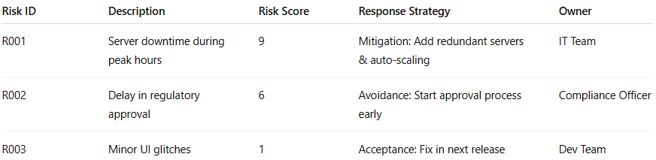
Risk ID | Description | Risk Score | Response Strategy | Owner
R001 | Server downtime during peak hours | 9 | Mitigation: Add redundant servers & auto-scaling | IT Team
R002 | Delay in regulatory approval | 6 | Avoidance: Start approval process early | Compliance Officer
R003 | Minor UI glitches | 1 | Acceptance: Fix in next release | Dev Team

🔑 Importance of Risk Response Planning
# Source: AI Source: Provided by: [Data Path: Persons Table -> ID Column: 1, Name_En Column: Motasem Essam] -> From: [Chatgpt (GPT‑5 Mini)] on [8/24/2025]
- Ensures proactive risk management.
- Reduces negative impacts and increases positive outcomes.
- Helps in resource allocation and decision-making.
- Provides stakeholders with confidence in project success.

✅ In short:
Risk Response Planning = The process of defining strategies and actions to handle identified risks, aiming to reduce threats and maximize opportunities for a project or system.

2-Risk Control

🔹 Definition
# Source: AI Source: Provided by: [Data Path: Persons Table -> ID Column: 1, Name_En Column: Motasem Essam] -> From: [Chatgpt (GPT‑5 Mini)] on [8/24/2025]
Risk Control is the process of planning, implementing, and monitoring actions to minimize the impact or likelihood of identified risks in a project or system.
It is a key step in risk management, following risk identification and risk analysis.

🛠️ Objectives of Risk Control
# Source: AI Source: Provided by: [Data Path: Persons Table -> ID Column: 1, Name_En Column: Motasem Essam] -> From: [Chatgpt (GPT‑5 Mini)] on [8/24/2025]
- Reduce probability of risks occurring.
- Minimize impact if risks do occur.
- Ensure preparedness through mitigation strategies.
- Monitor effectiveness of risk responses.
- Support decision-making to keep the project on track.

🔹 Risk Control Strategies / Responses
# Source: AI Source: Provided by: [Data Path: Persons Table -> ID Column: 1, Name_En Column: Motasem Essam] -> From: [Chatgpt (GPT‑5 Mini)] on [8/24/2025]
- Avoidance
  - Change plans or processes to eliminate the risk.
  - Example: Choose a more stable technology to avoid system failure.
- Mitigation / Reduction
  - Take steps to reduce the probability or impact of the risk.
  - Example: Add backup servers to reduce downtime risk.
- Acceptance
  - Acknowledge the risk but take no action; prepare contingency plans.
  - Example: Accept minor delays if impact is low.
- Transfer / Sharing
  - Shift risk responsibility to a third party (insurance, outsourcing).
  - Example: Outsource payment processing to reduce financial liability.
- Contingency Planning
  - Prepare action plans to respond if the risk occurs.
  - Example: Have a disaster recovery plan for server failures.

🔹 Activities in Risk Control
# Source: AI Source: Provided by: [Data Path: Persons Table -> ID Column: 1, Name_En Column: Motasem Essam] -> From: [Chatgpt (GPT‑5 Mini)] on [8/24/2025]
- Implement mitigation plans identified during risk analysis.
- Monitor risk indicators for early detection.
- Update risk register with status and outcomes.
- Communicate risks and actions to stakeholders.
- Adjust project plans based on risk control measures.

📊 Example Scenario
# Source: AI Source: Provided by: [Data Path: Persons Table -> ID Column: 1, Name_En Column: Motasem Essam] -> From: [Chatgpt (GPT‑5 Mini)] on [8/24/2025]
Risk: High server load may cause downtime.
Control Actions:
- Avoidance → Use a cloud provider with auto-scaling.
- Mitigation → Add redundant servers.
- Contingency → Have backup servers and a failover plan.
- Monitoring → Use server load monitoring tools.
Outcome: Risk is controlled, and the system remains available under peak loads.

🔑 Importance of Risk Control
# Source: AI Source: Provided by: [Data Path: Persons Table -> ID Column: 1, Name_En Column: Motasem Essam] -> From: [Chatgpt (GPT‑5 Mini)] on [8/24/2025]
- Reduces project uncertainty and surprises.
- Protects budget, schedule, and quality.
- Enhances stakeholder confidence.
- Ensures proactive management instead of reactive firefighting.

✅ In short:
Risk Control = The process of taking actions to reduce, manage, or respond to risks to minimize their impact and likelihood on a project or system.

